**b. i. & ii.**

> X10k = replicate(10000, max(rexp(n = 1,rate = 1/10),rexp(n = 1,rate = 1/10)))



**iii.**

> hist(x = X10k)

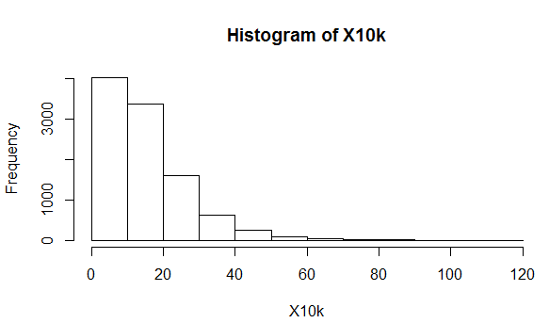

> pdf.T <- function(x){

+ return (0.2*exp(-0.1*x)-0.2*exp(-0.2*x))

+ }

> curve(pdf.T)

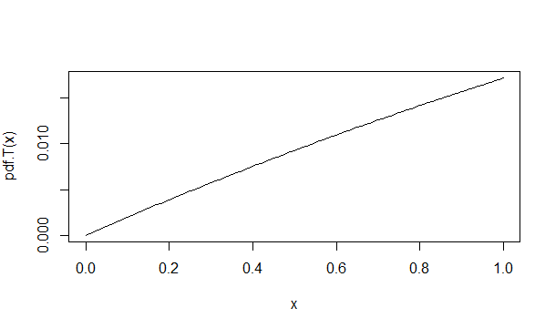

**iv.** E(T) =

> mean(X10k)



Analytically derived value 15 from probability density function is comparable to the Monte Carlo simulated value of 15.16811.

**v.** P(t>15) =

> 1-pexp(15,rate = 1/mean(X10k))

[1] 0.3719793

Since, the mean is different and sampling the data with 10000 random variables, there is a slight difference in probabilities.

**vi.**

**Test2:**

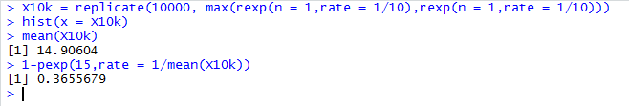

**Test3:**

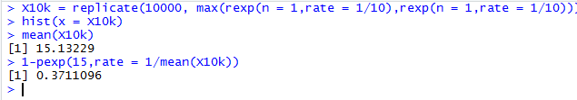

**Test4:**

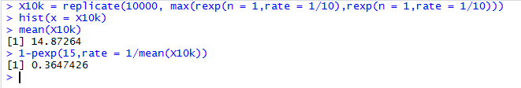

**Test5:**

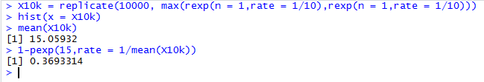

**vii.**

Sample=1000

**Test1:** 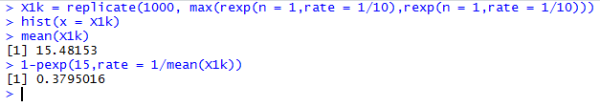

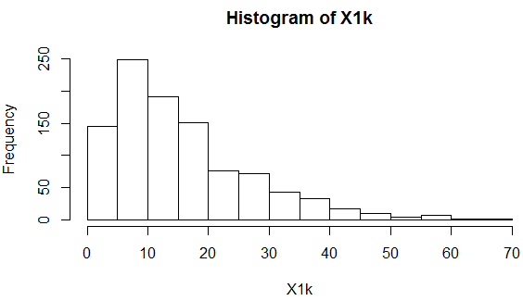

**Test2:**

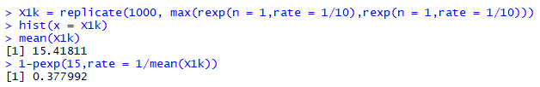

**Test3:**

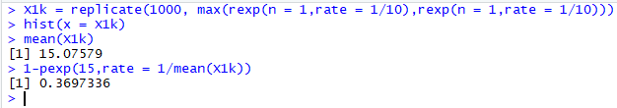

**Test4:**

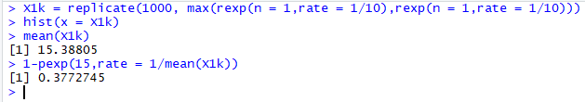

**Test5:**

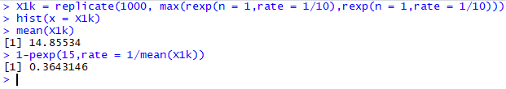

Sample=100000

**Test1:**

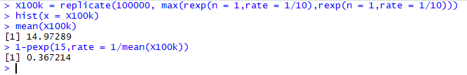

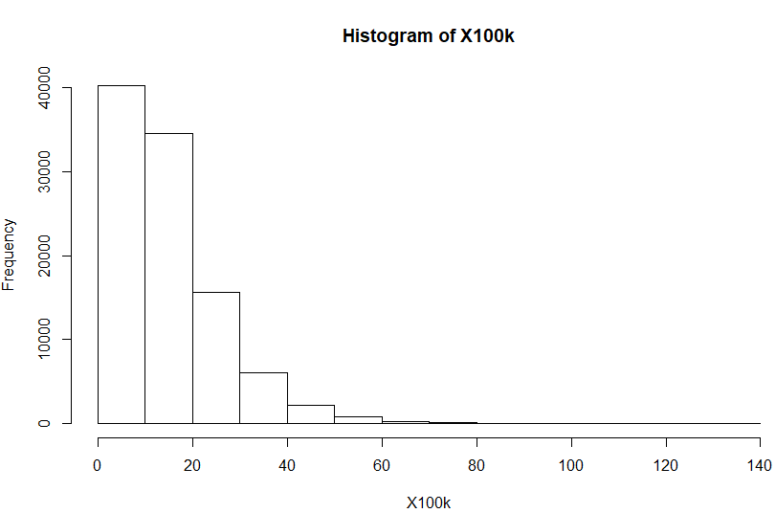

**Test2:**

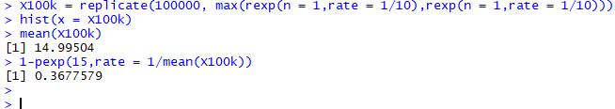

**Test3:**

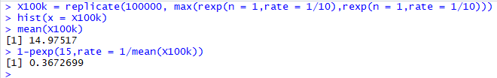

**Test4:**

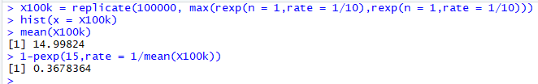

**Test5:**

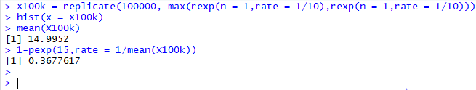

Observing the above results, a conclusion can be drawn as the sample size get larger the variation is reduced which follows Central Limit Theorem.

**2.** The following approach is used to find the value of pi:

1. Probability of point falling of circle under the space of a

square = $Area of circle÷Area of square$ = π/4

1. Generating a random number between 0 and 1 for x and y 10000 times.
2. Checking if the number falls under circle

> runs <- 10000

> x <- runif(runs, min = 0, max = 1)

> y <- runif(runs, min = 0, max = 1)

> in.circle <- (x-0.5)^2 + (y-0.5)^2 <= 0.5^2

> mc.pi <- (sum(in.circle)/runs)*4

> mc.pi

[1] 3.164

